

Oracle Cloud Deployment of Solar
V1.0
06th Feb, 2018

Contents
Revision Details: 2
Login to Oracle Cloud 3
Connect to cloud server through WinSCP 11
Install Docker on Cloud server 20
Setup MySQL docker container for Solar 21
Deploy Solar in Oracle Cloud server 21

Revision Details:

Version | Revision Date | Author | Reviewer | Approver
V1.0 | 06th Feb, 2018 | Pranava Kumari Vemula

Login to Oracle Cloud

- Go to https://cloud.oracle.com/home. Browse this url in Firefox as it is fast in firefox browser
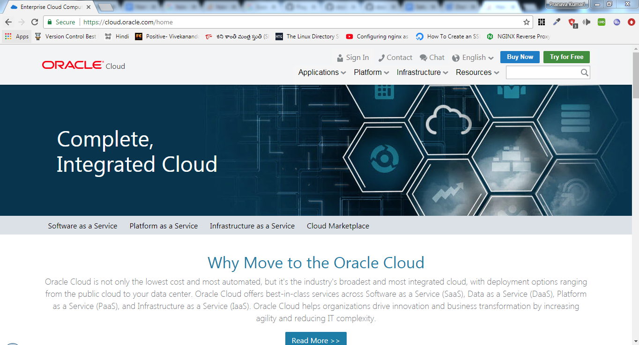

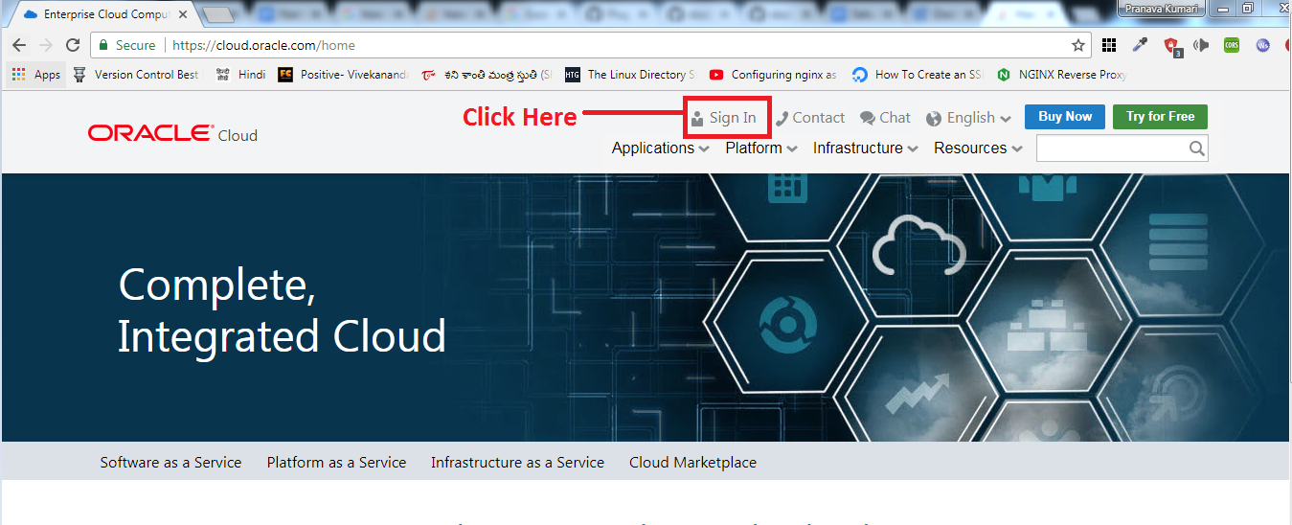

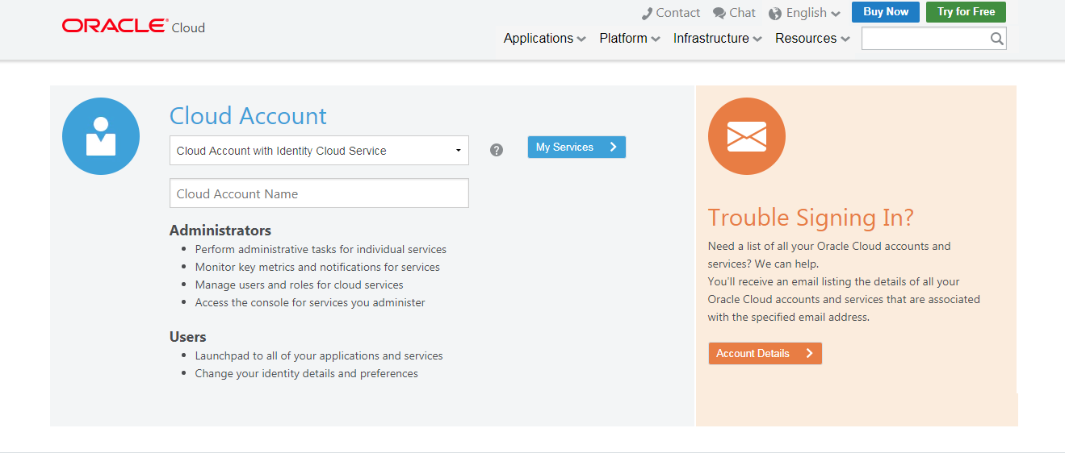

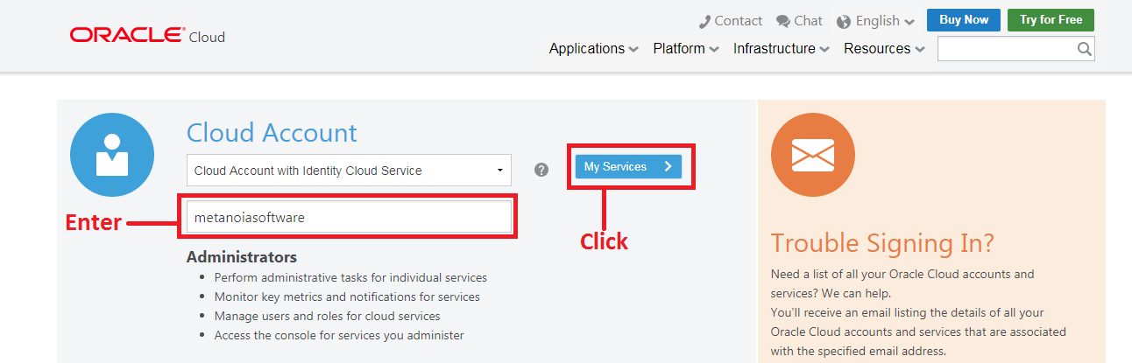

Cloud Account Name: metanoiasoftware
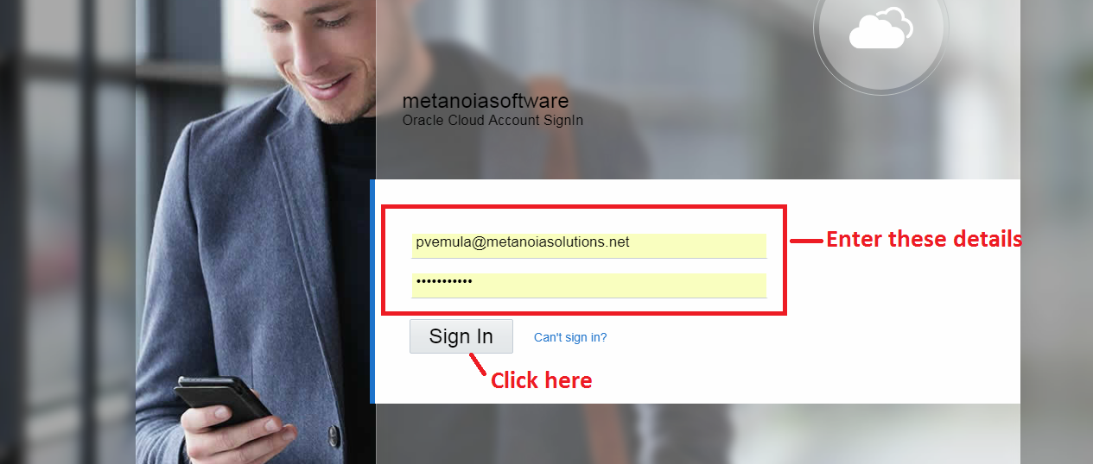

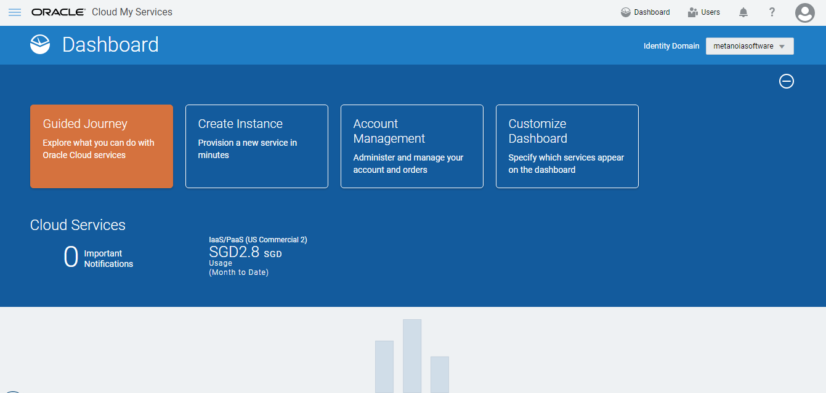

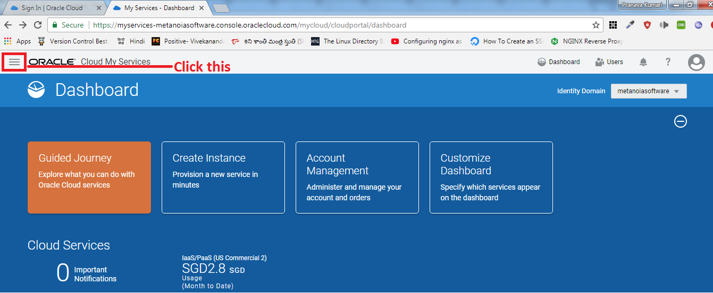

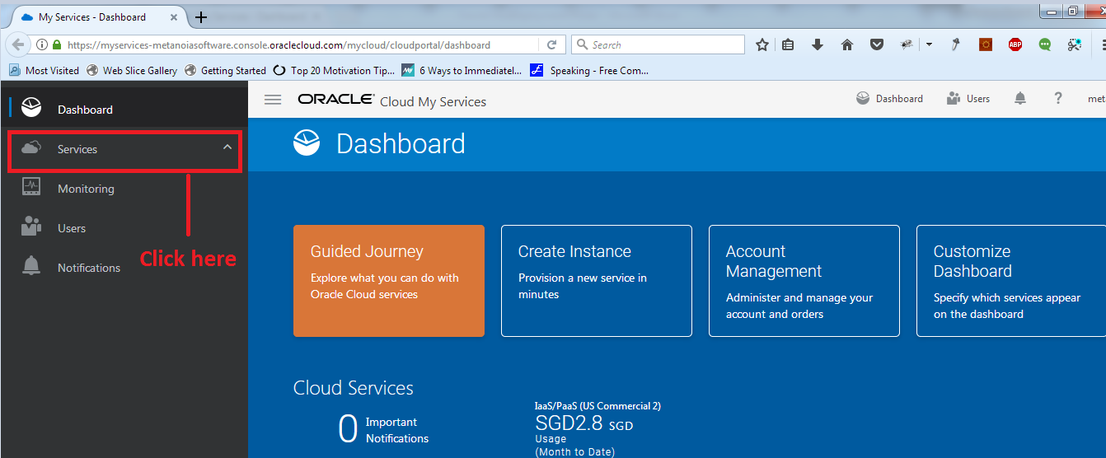
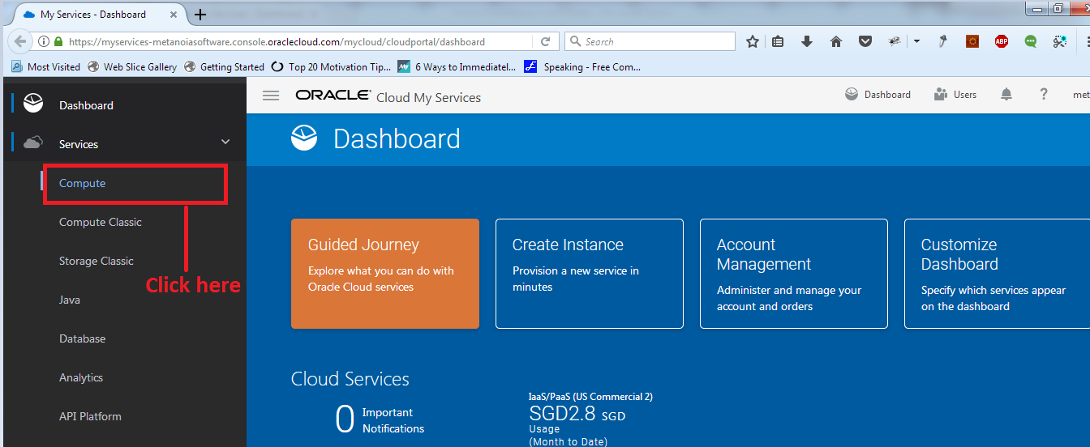

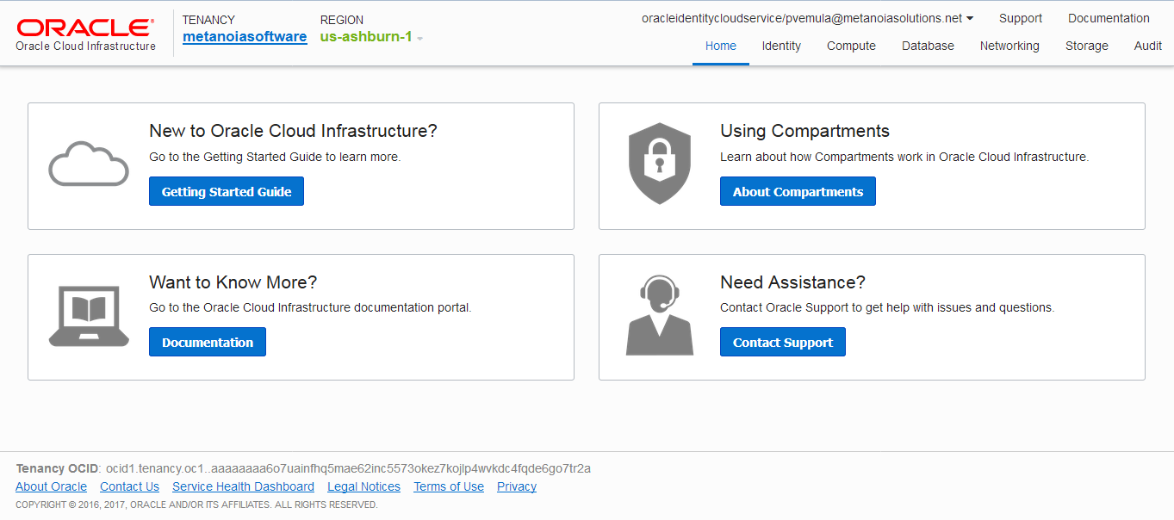

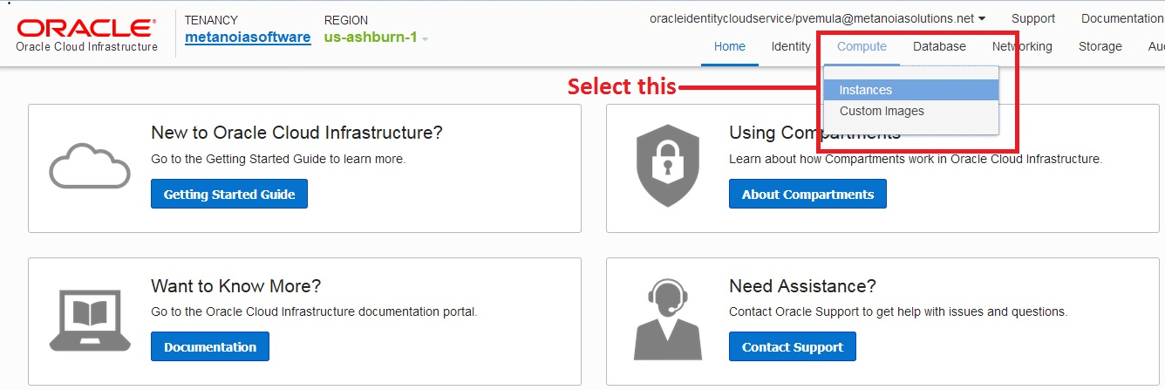

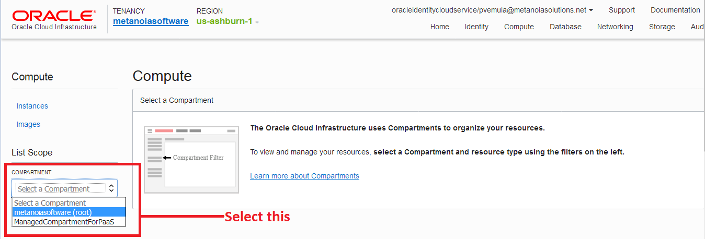

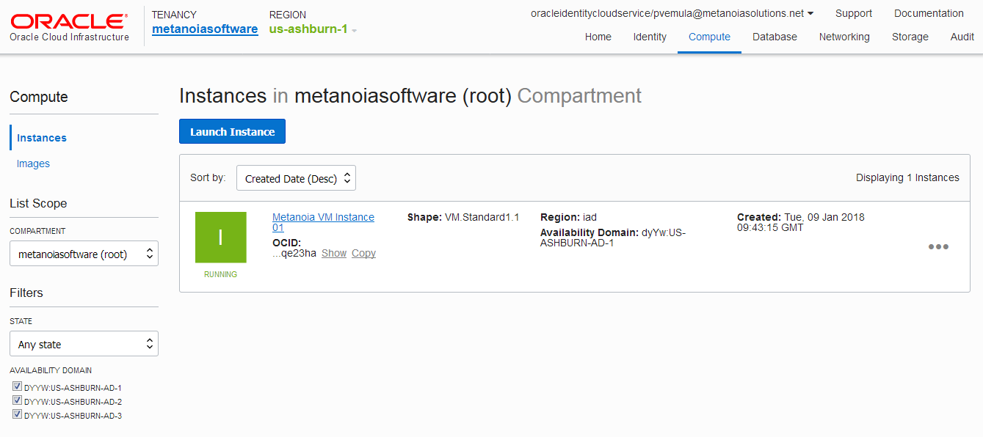

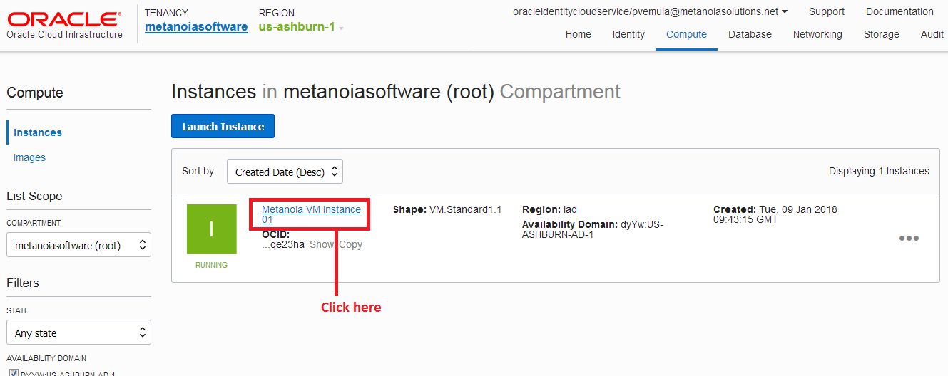

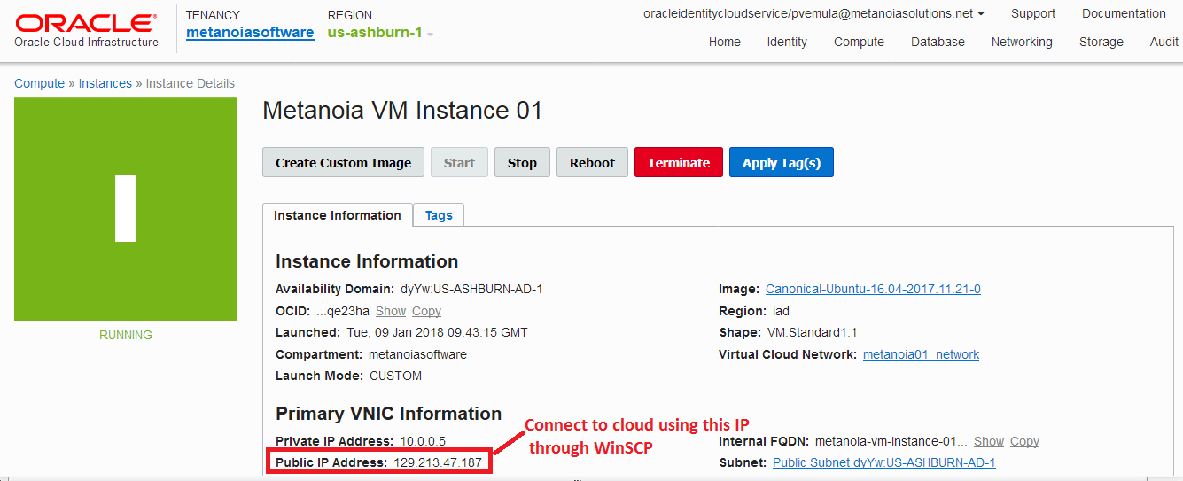

Connect to cloud server through WinSCP

- Start WinSCP and conncet to cloud server using its public IP address and with valid login credentials.
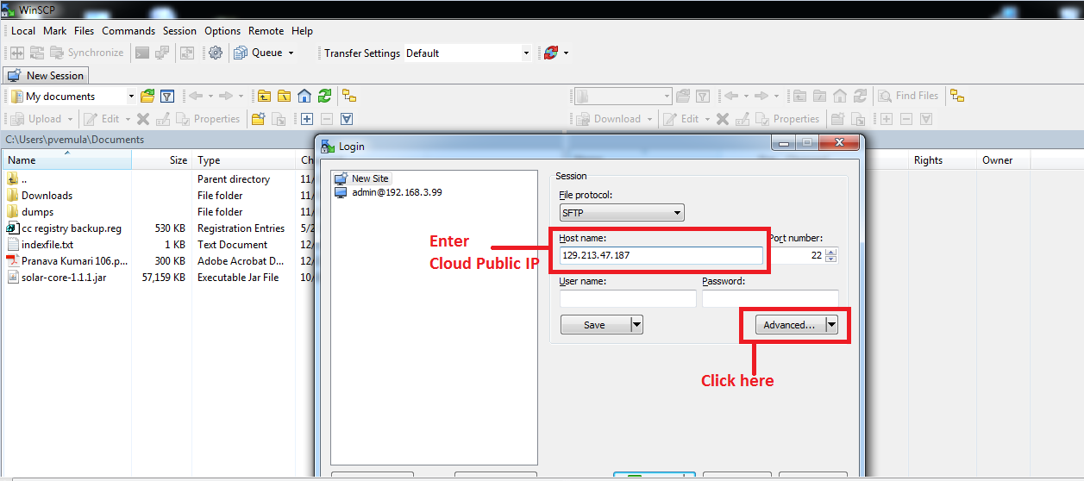
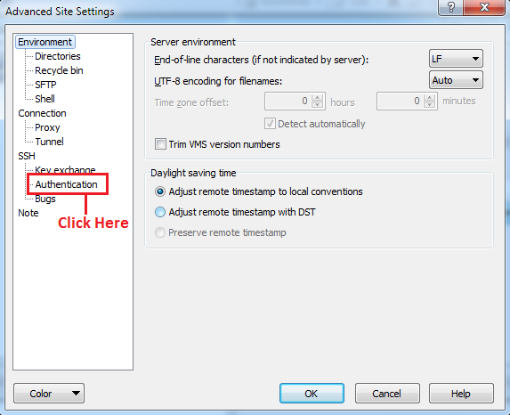
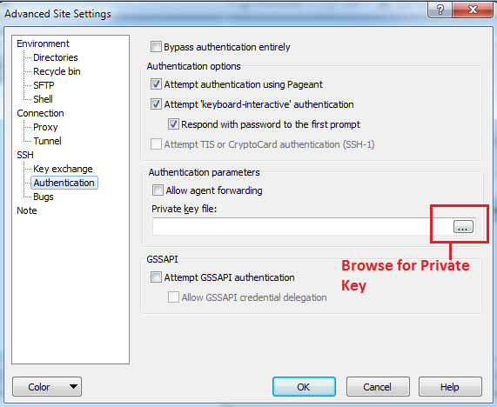

Note: If you don’t know about private key, please ask your lead
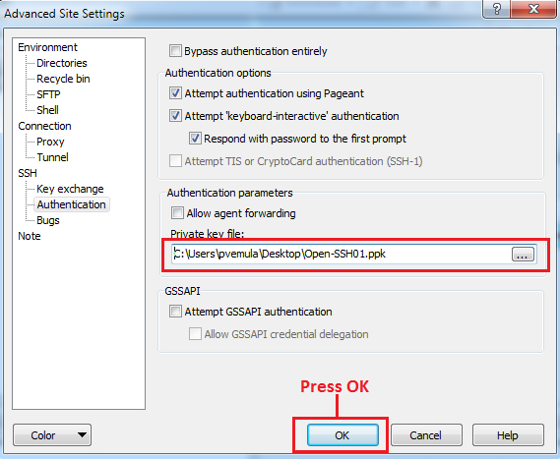
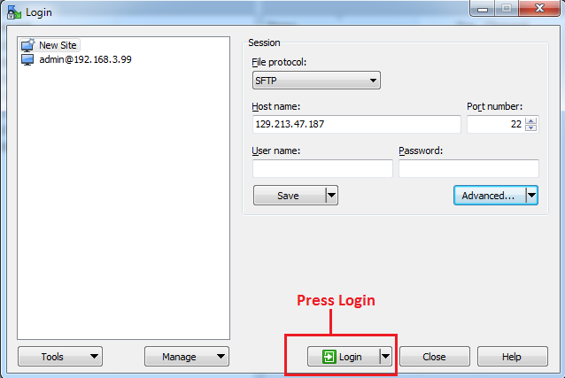
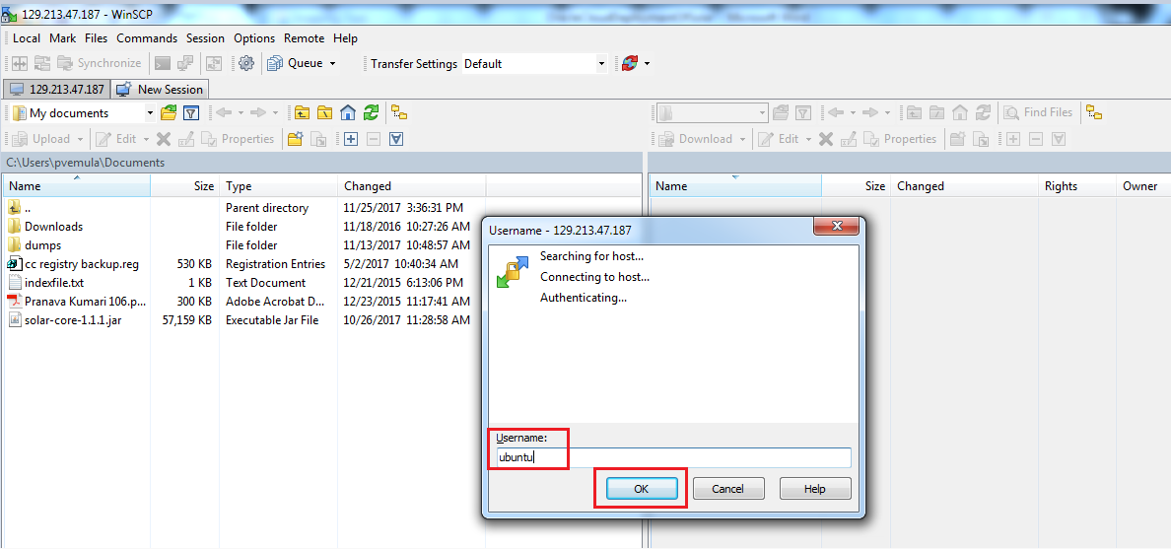
Note: Username – ubuntu
Enter username and press OK
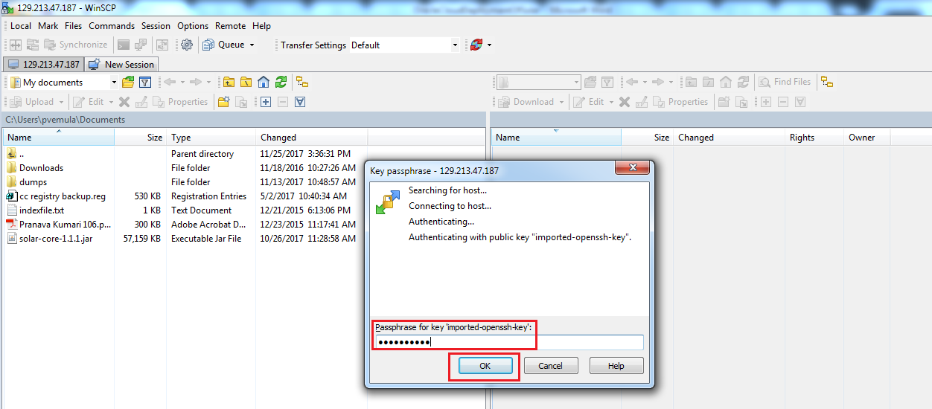

Note: Password is xY*SxCM9LW
Enter password and press OK
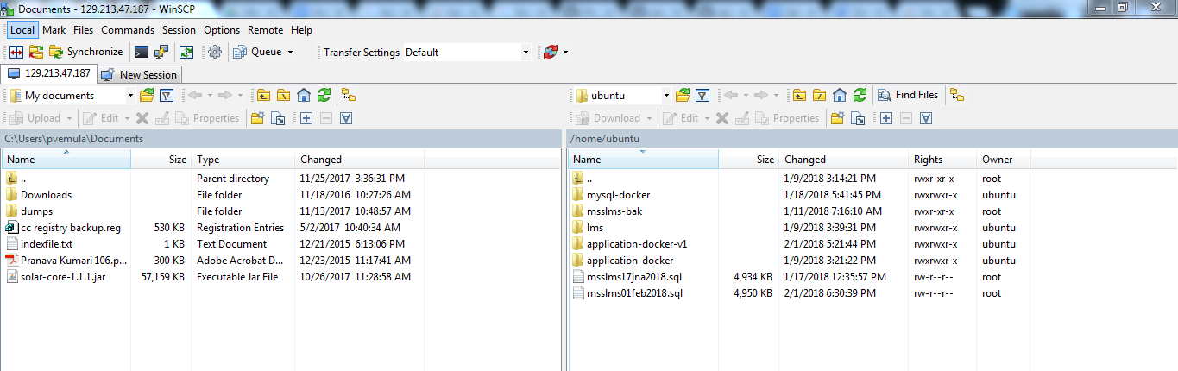
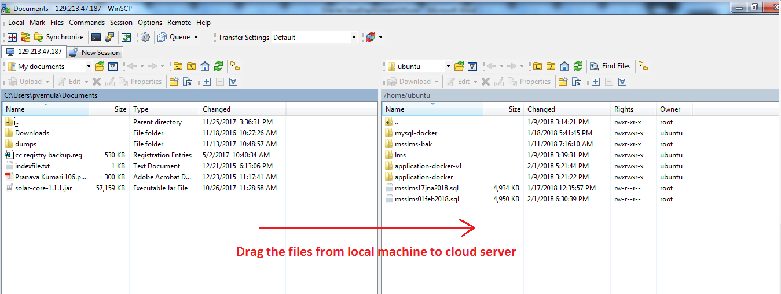

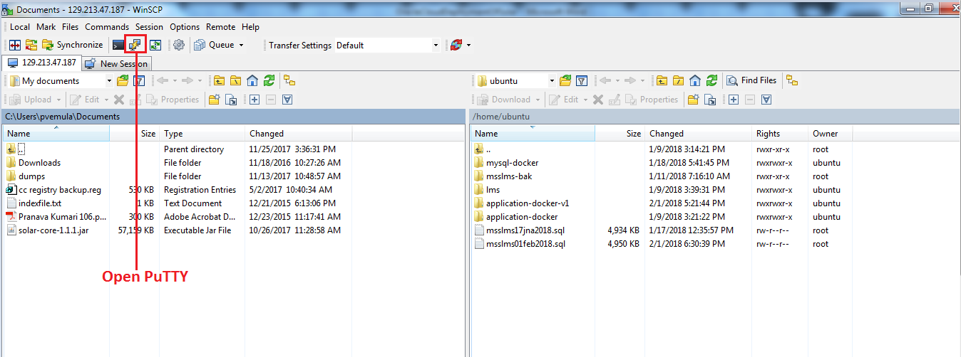

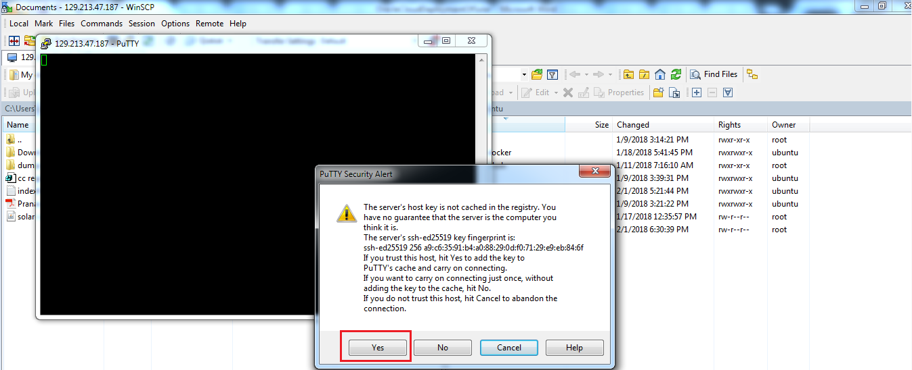
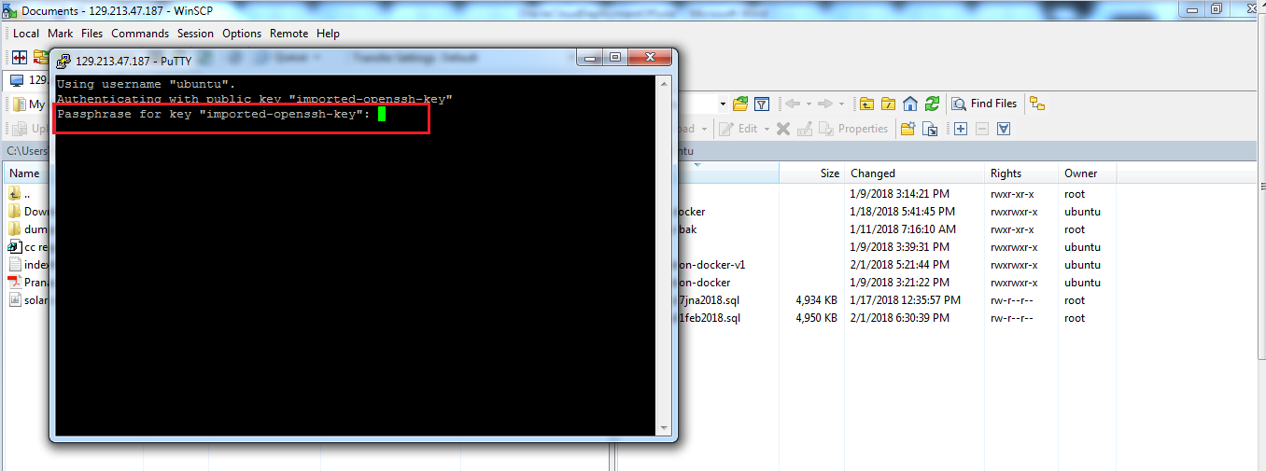
Note: Imported-openssh-key is xY*SxCM9LW
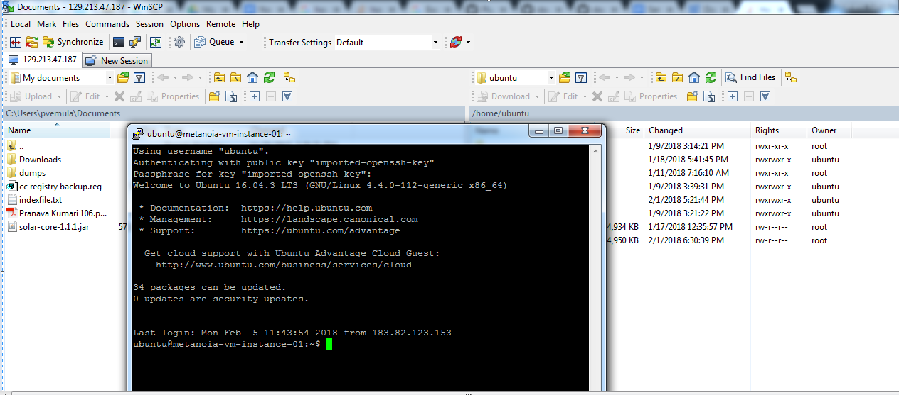
- Now go to root directory
$ sudo –s
$ cd /
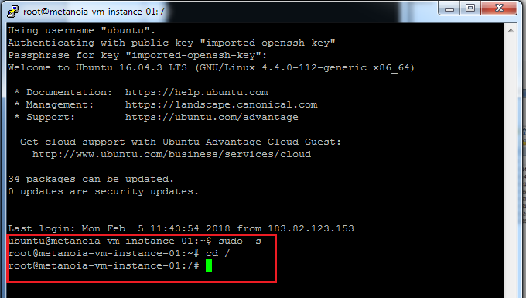

Install Docker on Cloud server

- We need to deploy Solar in oracle cloud using docker container
- To test whether docker is running in the cloud server or not, use following command
$ service docker status
(OR)
$ systemctl status docker
(OR)
$ /etc/init.d/docker status
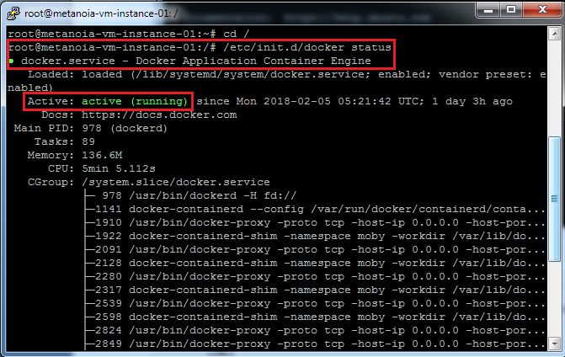
- If the response is like above screenshot, then no need to install docker in cloud server as it has already installed.
- If the response is docker- inactive, then you need to start the docker as following
$ service docker start
(OR)
$ systemctl start docker
(OR)
$ /etc/init.d/docker start
- If the response is “Docker not found”, then install docker. Please refer the document to install docker at https://drive.google.com/file/d/1JMEx-RVUJykB80CTXt1ERgX3LfZS-GZD/view
Please refer Section 2 – Installation and Uninstallation of Docker on ubuntu

Setup MySQL docker container for Solar

- Please refer section 11 – Setup MySQL docker conatiner in the following document
https://drive.google.com/file/d/1JMEx-RVUJykB80CTXt1ERgX3LfZS-GZD/view

Deploy Solar in Oracle Cloud server

- Please refer section 12 – Deployment of Solar application in docker container in the following document
https://drive.google.com/file/d/1JMEx-RVUJykB80CTXt1ERgX3LfZS-GZD/view

